Extra talking notes on the Outline
(Slide Page 3) Predict your cashflow, A/P expenses, how much income do you need monthly to meet expenses?

Definition of cashflow: money that comes in, money that goes out
Definition of A/P: Accounts Payable- the bills that your organization has to pay

Example of how I do it:
Payroll is approx. 142K a month, or 71K twice a month, need to be ready for that.
As for A/P expenses- you will learn what is quite constant such as the cost of utilities and rent. Doesn’t fluctuate too much.
When you create and submit a budget to a funder, you will more than likely know when those expenses will occur and can predict when it will happen.

Example prediction: Domestic Violence Awareness Month in October may have venue expenses, snacks, interpreting costs, event supplies needed and you can add those amounts to the 142K Payroll cost, rent, utilities, and it may be approx. 150K for October.

Example 2: Your state will have a coalition conference in May. You figure that you will need to purchase plane tickets and registration in the month of March. Add those 2 expenses to your rent, utilities, and 142K payroll and it may be 147K for March.

Example 3: It is now May and the same conference now has a hotel expense, per diem and ground transportation that you need to take into consideration along with your usual rent, utilities, 142K payroll cost and the month of May, may come out to 145K.

(Slide Page 3)- Where does your funding come from? It influences the type of audit you have.

If you spend 750K or more in Federal dollars (for example- OVW, OVC, any funding from the government), a “single audit” (government’s name for it) is required and this is the top level audit that you can receive. It is the most intensive. If you meet the threshold of 750K, then the cost of the audit is an allowable cost to the federal grant. If you have other funders to also pay a portion of the audit cost, then need to make sure the cost is allocated correctly.

If 750K or less, you can have what they call a “yellow book audit” which is the Generally Accepted Gov’t Auditing standards for organizations receiving gov’t awards. It’s less intensive. If you do not meet the threshold of 750K then the cost of the audit is not allowable to the grant program.

If you obtain mostly fundraising or private funding, you could just have a financial review by a CPA (Certified Public Accountant) to ensure financial integrity

(Slide Page 4)- What are internal controls?
This is a document of the agency’s policies and procedures that is used to achieve the following: safeguarding the organization’s assets from accidental loss or fraud, ensure the reliability and integrity of financial information, ensure compliance with many federal, state, and local laws. It simply involves everything that controls risks to an organization.

(Slide Page 4)- How does internal controls increase your financial reliability and integrity? What does this mean?
-Example of internal control procedure monitoring the mail and check deposit process:
- mail is received, processed and initialized by all staff (if you have 1-3 employees only for instance, or board?)
- checks that are received are signed by the ED and one other person on the lower left corner
- checks are then copied and processed for deposit and both the ED and the other person reviews the deposit for accuracy
-the other person takes the deposit to the bank (not the ED)
-External CPA reconciles the bank statements to your financial software on a quarterly basis and signs off on all reconciliations
-bottom line- more eyes and initials on everything, the better

-Example of who has access to what?
-ED and Board President has access to sign checks & bank card
-staff person has access to online banking and reconciles receipts with bank card but not the ED or Board President
-try to create a way where different people have different kinds of access and not have the same access

(Slide Page 4)- Reduces the possibility of fraud.

What does this mean? What kind of fraud, like what?
Fraud examples:
- financial abuse with embezzling funds, not accounting for each dollar/penny, but hiding some funds for yourself
-someone asks you to record a transaction incorrectly or prepare a report that you were uncomfortable with
-hiding mail that was received that you do not want someone else to know about
-staff person that runs payroll changes their paycheck amount to be different than what was agreed by the ED
-bottom line- more eyes and initials on everything, the better

(Slide Page 4)- Helps to ensure compliance with laws, regulations and funder expectations (read contracts!)
Examples of financial requirements under ADWAS’s DSHS contract (this is a contract that has combined state / federal dollars):
-Maintain internal controls
-Shall not subcontract with other organizations without DSHS’s approval
-15% of contract total on administrative costs may be used, no more than that (you will need to prove that you didn’t spend over 15% of admin costs)
-ensure that the work performed is not charged to another grant (double dipping), (how do you prove that you didn’t charge 2 different funders for the same thing?)
-meals and refreshments must be an integral part of the meeting, training or event (you will need to justify why you want funds for these)
-prohibited from charging clients for services

(Slide Page 4)- establishes monitoring procedures on various financial activities
-earlier we covered the mail and check deposit process, but that is not the only financial activity that occurs
More examples:
Create a process for A/P invoices that are received in the mail:
-mail is received, processed and initialized by all staff (if you have 1-3 employees only for instance, or board member?)
-Invoices are separated out from the other mail and initialized by all staff (or board?), ED ultimately approves the invoice with an approval stamp specifically with ED’s initials and date
-Vendors are approved by the ED through the aforementioned step
-ED ensures the invoices are authentic and genuine and that the service did happen at your organization’s request
-ED asks around if the expense is not a familiar one and gets the answer first before approving
-ED provides all invoices to accounting
Create a process for paying organization’s expenses:
-Disbursements are made only for goods and services (ie: office supplies, interpreting services) that was authorized earlier such as it is listed in the funder’s budget
-ED authorizes all expenditures through the A/P Invoice process mentioned earlier
-Program Director may approve in ED’s absence
-check signers must receive the supporting document(s) behind the check before they can sign the check

(Slide Page 4)- Safeguards all funds awarded and contributed to your organization- what is this?
In your internal controls document creation process, you should mention what your organization does to keep track of how your organization’s money is expended. To keep awards safe, do not double dip. This means that you charge a $300 expense to two or more funders when it should be charged to just one. However, if you SPLIT a charge between more than 1 funder, at $150/each, this is fine.

For example, ADWAS uses Quickbooks Desktop Pro that allows me to list all funders we have and I am able to assign specific funders to expenses and it cannot be repeated once assigned, and therefore no double dipping happens. The assignment of a funder’s name also helps us keep track of what funding we have remaining on funder budgets. Therefore our gov’t awards are safe in our hands with our processes in place.

Also- another strategical mechanism that can be used to show how the organization tracks it’s expenses to various funders- TIMESHEETS/TIMECARDS. The highest expense in most organizations is payroll, so this is a good place to have a good system. Timesheets should clearly reflect time spent on specific projects/grants.

Pix of timesheet sample
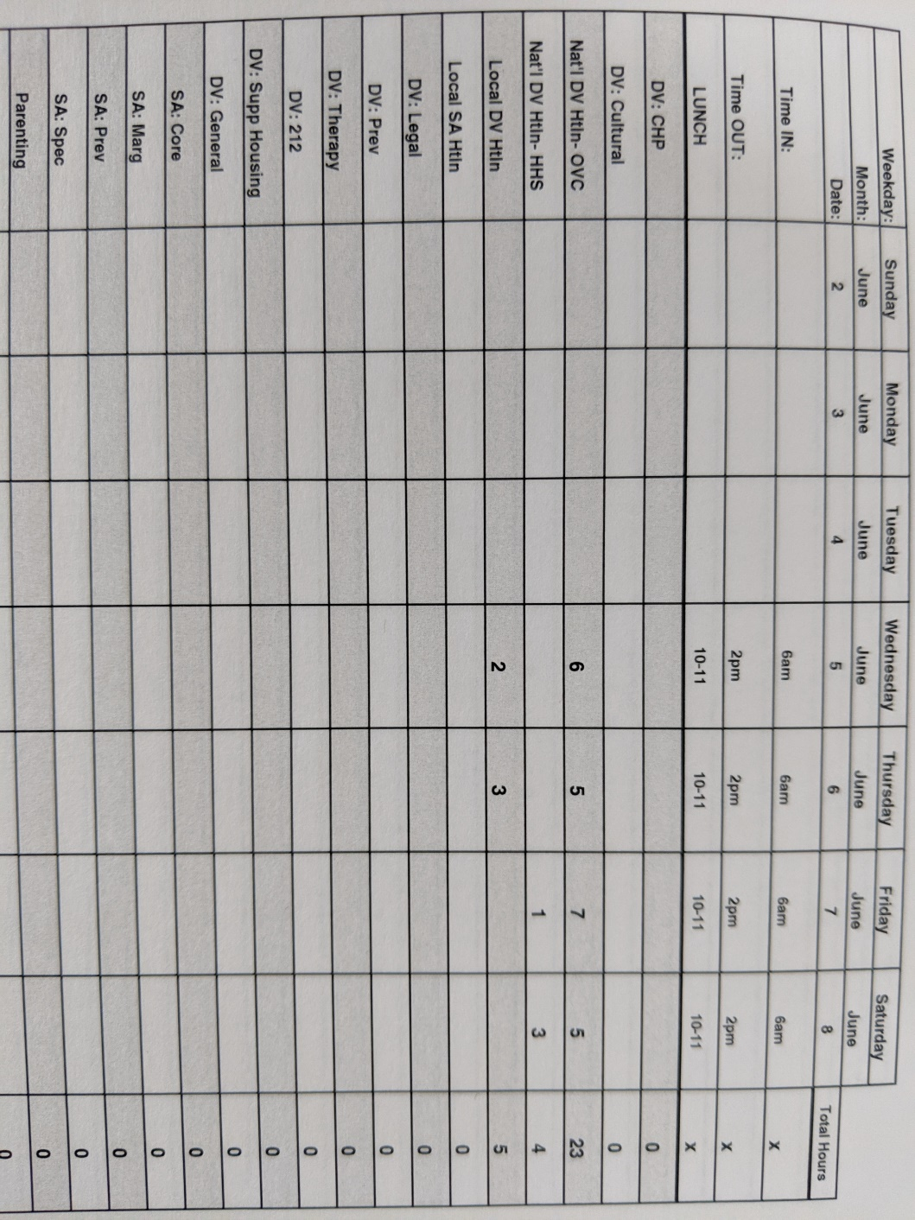

(Slide Page 5)- Read all funder contracts and make a list of financial items that you need to have in place in order to be in compliance…
I mentioned a few items from ADWAS’s contract with DSHS to show how we are aware of and how we comply with their financial requirements. Bottom line, it is easier to create a document and list the financial requirements of a government contract so it is easy for you to refer to it and also show the funder u have that if they ask how you keep track and auditors too.

(Slide Page 5)- DOCUMENTATION!
-whatever you do with your work, always document your process on how you got to that point. Do your work as if someone will look at your work and understand it. Write notes on invoices, write notes on check copies, do not keep everything in your brain because you will forget during the audit when they ask you questions on how did you decide to do something a certain way?
Example:
The budget indicates you will spend 65% of your time on that grant. Therefore it follows that a utility bill should show a 65% charge to that grant and 35% charge to your organization’s fundraising or private funding. Write down on the $500 utility bill 65% = $325 to DOJ and $175 to ADWAS. We can budget for 65% of the costs, but the charge to funder must be based on the actual time spent during a period. It may be 50% for example if only 50% of your time was spent on the grant instead of 65%.

At the time of a funder audit request or annual audit request, the person reviewing your paperwork will understand exactly what you did and you will not need to hold this information in your head for a long time until an audit or external CPA consultant asks you about it. You will be able to show them the funder budget indicating the 65% or your 50% time spent and how the remaining 35% (more or less) falls on the organization to pay the remaining through other efforts.

Documenting everything you do is the best way to go. Once a system is developed, it will be easy to document. Every time a new process is adopted, it takes time to adjust to the documentation process.

